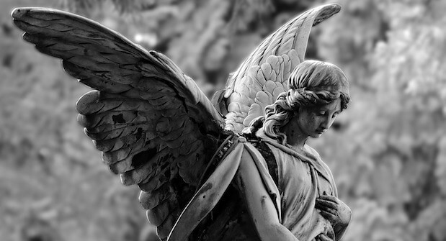
We must teach our children that the ground beneath their feet is the ashes of our grandfathers. So that they will respect the land, tell your children that the earth is rich with the lives of our kin. Teach our grandchildren what we have taught our children, that the earth is our mother. Whatever befalls the earth befalls the sons of the earth. If men spit upon the ground they spit upon themselves. we can heal the Earth and make it like it was a long time ago.”

